--=================================================================================

--============================== CIS 310 ASSIGNMENT 6===============================

--=================================================================================

/*

STUDENT NAME: Jacob Palmer

STUDENT ID: 5262256

SUBMISSION DATE: 3/9/2024

*/

**-- 1.** Execute the script for the StayWell database (from Database Chapter 1 file folder) in Microsoft SQL Server to create and populate the database. (10 pts)

Create an entity relationship diagram for the StayWell database in Microsoft SQL Server. **You must connect the tables with proper relationships, below example screenshot do not contain the answer.** Use the given data and your learning from database designs, to determine which table is on the one side and which is on the many side in each relationship. *Reminder, the shared attribute/column names can be different on the connecting tables.

**Use a tool such as Snipping Tool to screen capture the ERD and paste it here.**   
Your screenshot must show connection to **YOUR database**, as shown in example or will receive 0.

My Screenshot: (For some reason, it would hide what was highlighted in the sample on my screen, anytime I opened this database design file. Hopefully I can still prove this is my own work.)

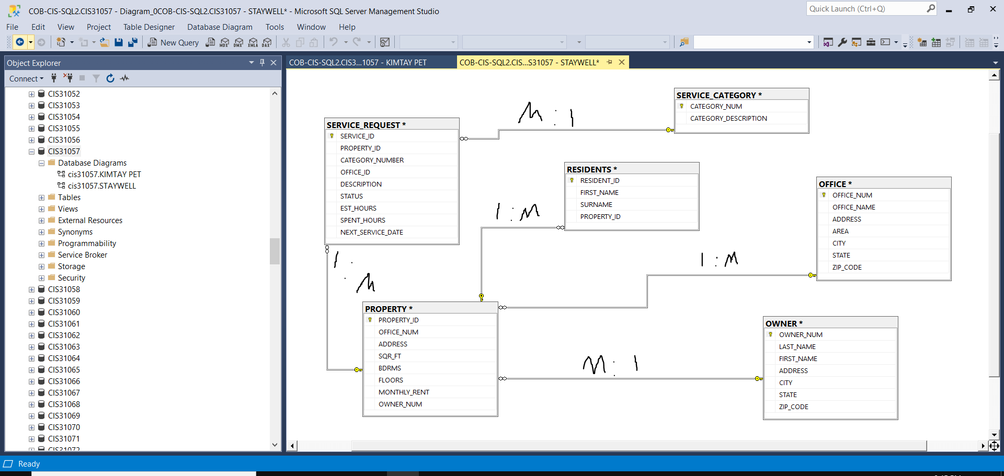

**--2.** Provide the SQL script for creating a SHORT_TERM_RENTAL table with the structure shown below,

PROPERTY_ID should be the only Primary Key for this table. (5 pts)

/*

**==Column Name== | ==Data Type===**

| PROPERTY_ID | NUMERIC

| OFFICE_NUM | NUMERIC

| ADDRESS | VARCHAR(30)

| SQR_FT | NUMERIC

| BDRMS | DECIMAL(2, 0)

| FLOORS | INT

| WEEKLY_RENT | NUMERIC

| OWNER_NUM | CHAR(5)

*/

DROP TABLE IF EXISTS SHORT_TERM_RENTAL;

CREATE TABLE SHORT_TERM_RENTAL (

PROPERTY_ID NUMERIC PRIMARY KEY NOT NULL,

OFFICE_NUM NUMERIC,

ADDRESS VARCHAR(30),

SQR_FT NUMERIC,

BDRMS DECIMAL(2,0),

FLOORS INT,

WEEKLY_RENT NUMERIC,

OWNER_NUM CHAR(5)

);

**--3.** Provide a screenshot of SHORT_TERM_RENTAL table's metadata. (5 pts)  
--Your screenshot should show all 8 rows and the first 8 columns, and **your username CIS310XX** at the bottom. Example as below:

--*Reminder: In Microsoft SQL Server, you may execute "EXEC SP_COLUMNS Tablename;" command to see the metadata (data about the data). in the output, (where Tablename is the name of the table whose structure/metadata you want to show.)

**--4.** Provide the SQL script for inserting below record to the SHORT_TERM_RENTAL table. (2 pts)  
--* Reminder that text type data should be encased in the appropriate symbols.



INSERT INTO SHORT_TERM_RENTAL VALUES (13, 1, ‘5867 Goodwin Ave’, 1650, 2, 1, 400, ‘CO103’);

**--5.** Provide the SQL script for deleting SHORT_TERM_RENTAL table from the SQL server. (2 pts)

DROP TABLE SHORT_TERM_RENTAL;

**--6.** Provide the SQL scripts to output the **metadata** of the STAYWELL tables. (3 pts)  
Note that there are 6 tables. Therefore, there should be 6 statements.

EXEC SP_COLUMNS PROPERTY;

EXEC SP_COLUMNS RESIDENTS;

EXEC SP_COLUMNS OWNER;

EXEC SP_COLUMNS OFFICE;

EXEC SP_COLUMNS SERVICE_CATEGORY;

EXEC SP_COLUMNS SERVICE_REQUEST;

**--7.** Provide the SQL scripts to output the **contents** (all columns and rows) of the STAYWELL tables. (3 pts)  
Note that there are 6 tables. Therefore, there should be 6 statements.

SELECT * FROM PROPERTY;

SELECT * FROM RESIDENTS;

SELECT * FROM OWNER;

SELECT * FROM OFFICE;

SELECT * FROM SERVICE_CATEGORY;

SELECT * FROM SERVICE_REQUEST;